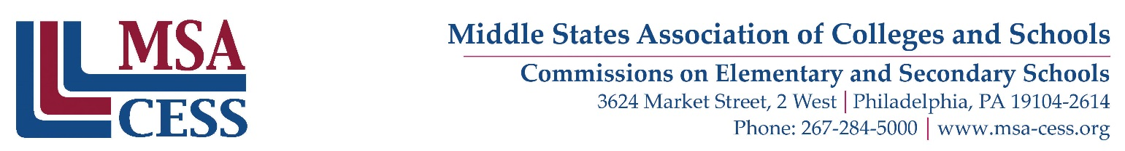

MSA REPRESENTATIVE REPORT

I, Click or tap here to enter text. served as the Middle States Association Representative to Click or tap here to enter text. on Click or tap here to enter text. and assessed the school's level of meeting the 12 Middle States Standards for Accreditation.

Do you feel the school's compliance with the requirements of the cooperative's protocol serve as an equivalency for MSA requirements for accreditation?
If not what additional information should the school be required to submit?
Click or tap here to enter text.

Overall Comments:

Click or tap here to enter text.

Click or tap here to enter text. | Click or tap here to enter text.
SIGNATURE OF MSA REPRESENTATIVE | DATE
Thank you for your service to Middle States Association Commissions on Elementary and Secondary Schools and their partner associations.

