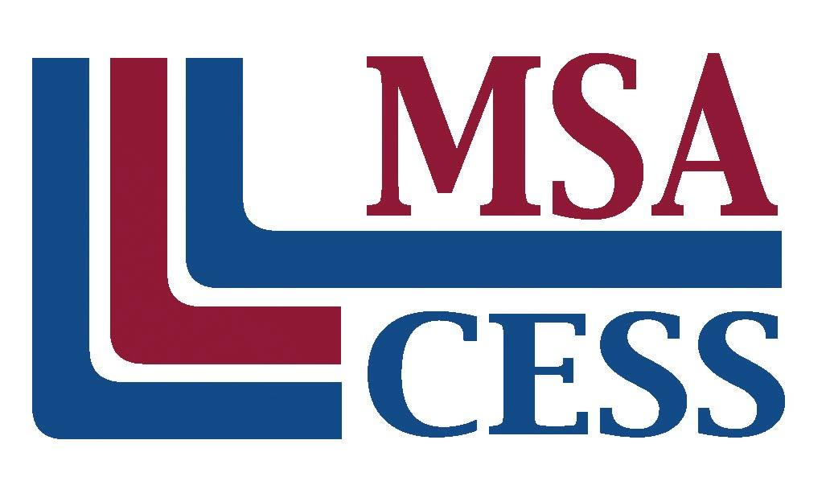
Middle States Association of Colleges and Schools
Commissions on Elementary and Secondary Schools
Phone: 267-284-5000 | www.msa-cess.org

TEAM VISIT
ORIENTATION AND TRAINING AGENDA

- Welcoming Remarks

- Introductions

- Overview of the Self-Study Protocol

- Purposes and Expected Outcomes of the Team Visit

- Role of the Visiting Team Member

- Results of the Pre-Visit

- Logistics for the Visit

- The Schedule and Procedures
  - The Team Visit Schedule
  - Interview Techniques and Interview Questions
  - Writing Assignments
  - Writing the Report

- Review of the Content of the Plan
- Analysis of the Mission
- Analysis of the Beliefs
- Analysis of the Profile of Graduates
- Familiarization with the Student Performance Objectives
- Familiarization with Organizational Capacity Objectives
- Review of the Self-Assessment of Standards for Accreditation

  - Organize for the First Day

