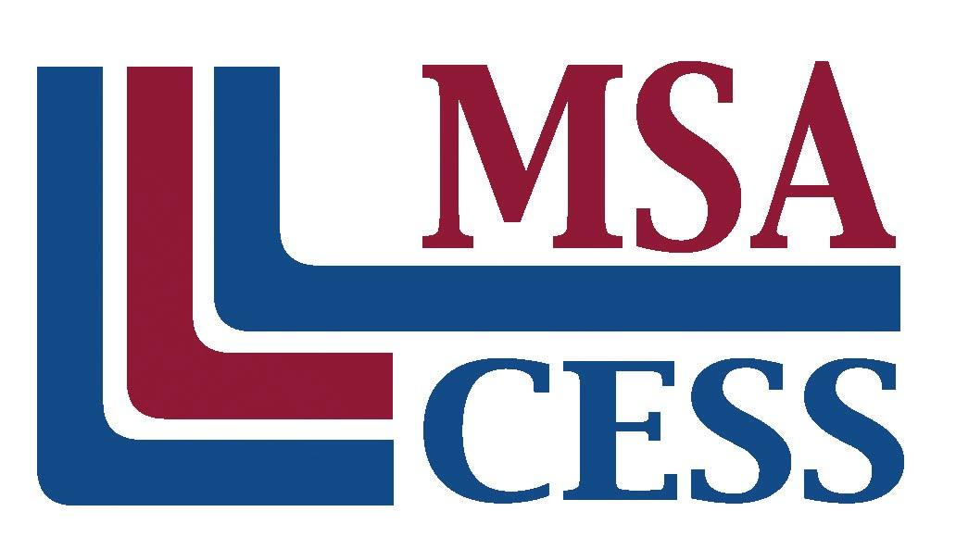
Middle States Association of Colleges and Schools
Commissions on Elementary and Secondary Schools
Phone: 267-284-5000 | www.msa-cess.org

Note: Below you will find a sample letter for your first contact with your team members. The letter should be sent immediately after your pre-visit to the school.

Dear ____________________,

Welcome to the Middle States Visiting Team for [Name of School] in [City, State]. We have an interesting and exciting task ahead of us. I am grateful for the opportunity to work with you and to share your professional expertise in the field of education. An accreditation visit is considered to be one of the best professional development experiences available.

I visited [Name on School] on [Date] and met with school administration and many of the teachers with whom we will be working in a few short weeks. I spent time reviewing the forthcoming visit with [Name and Title of the person(s) with whom you met] as well as touring the school facility and accommodations. This visit gave me confidence that the school staff is well prepared and that our visit will be successful.

During my visit we worked on the schedule and the logistics of the visit. The team’s first event will be our orientation meeting at the [Name of place of lodging and address] at [Date and Time of 1st meeting]. [Name of person who will be sending directions] will communicate with each of you with specific information including directions to [Name of Lodging]. Include the schedule for the rest of the first day. The visit will conclude with the oral report at [scheduled time] on [day and date].

You will receive an email invitation from the MSA Office to access a Google shared drive which will include all team materials, the school’s self-study, supportive evidence, and video tour.

The self-study is the foundation of our evaluation. It is expected that you read and develop a basic familiarity with the contents before our visit begins. The interviews you conduct will focus on the contents of this document. You will need to know the contents as we seek to ascertain:
● the quality of the school’s planning processes,
● how well the school meets the 12 MSA Standards for Accreditation,
● the degree to which the entire school community is knowledgeable and supportive of their chosen improvement objectives,
● the quality of the strategies and action steps.
It is helpful to note questions and to highlight strengths and concerns as you read the report. If you have any questions, please know that I am available to you. Feel free to contact me by phone or email.

Enclosed is a Visiting Team Member Questionnaire. I ask that you complete and return to me by email no later than [Date]. Be sure to include which areas of the report you feel comfortable leading. Each of us will be responsible for writing several areas. I will send you your areas of responsibility as soon as I hear from each team member. Please bring with you your written expectations based on what you read in the self-study. The expectations compared to what we actually see at the school will be the basis for our discussions. Each of us will be expected to contribute insights to each area of the team report.

If you have not already done so, I highly recommend you sign up to attend the MSA Team Member Briefing webinar. It will give you a helpful overview on what to expect as a team member. You can sign up at a convenient time for you by following this link:
https://www.msa-cess.org/team-member-training/

Thank you for your willingness to serve on this team. I look forward to meeting you and hope that this will prove to be a rewarding experience for you both professionally and personally.

Sincerely,

