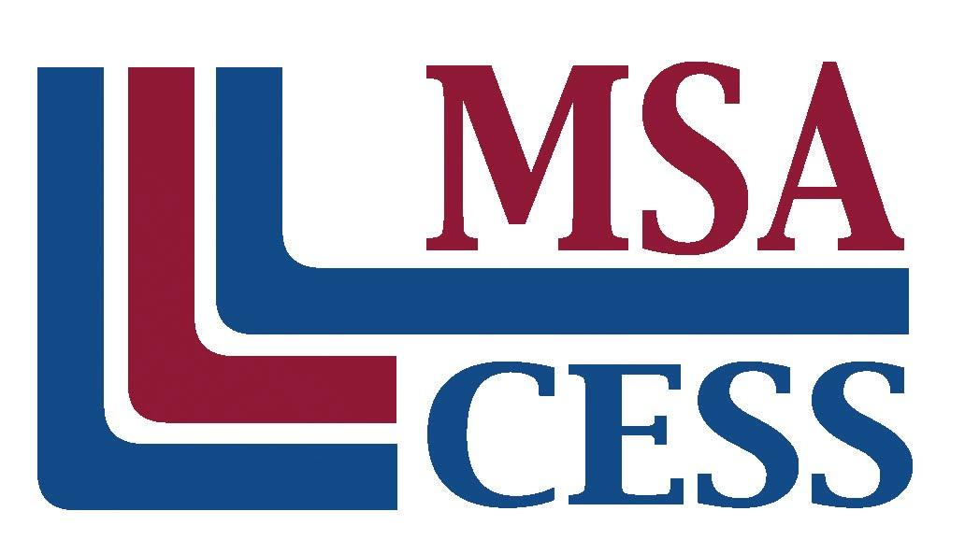
Middle States Association of Colleges and Schools
Commissions on Elementary and Secondary Schools
Phone: 267-284-5000 | www.msa-cess.org
Note: Below you will find a sample letter for your second contact with your team members. The letter should be sent approximately 2 weeks prior to your visit to the school.

TO: Members of the Visiting Team for [Name of School and Dates of visit]

Our visit to [Name of School] is approximately two weeks from today. I hope you have received the self-study from the school, and that you have started the process of familiarizing yourself with the school through this document and the school’s website [include website address; can be found on msa-cess.org]. The contents of the self-study document and your expectations will serve as the starting point for our analysis of the school. You will gain additional information and data through observations, interviews, and examination of documents. As you read the self-study, you should begin to make note of questions you will want to ask or documentation you will want to examine to develop a clear understanding of the school.

It is important to pay particular attention to the areas for which you will be responsible. I am [enclosing or attaching] the list of team assignments. Please note that our team has [number of members], and we will be operating as a committee of the whole. Each of us will be expected to contribute insights to each area of the team report. I have also [attached] a tentative schedule our team will follow throughout the three and one-half days of the visit.

The school has arranged for us to stay at [Name and Address of lodging]. We will meet [time and place] for the team orientation and training session. In the training session, I will provide you with the knowledge and information you will need to fulfill your responsibilities as a team member. This training is critical for us to develop a clear understanding of the standards and expectations by which we will evaluate [Name of School] and how to apply our understanding of the process.

The school will reimburse you for your travel expenses. Please keep a record of your mileage and toll receipts. The school will also pay for your lodging and all of your meals during the visit through direct billing to the school. However, you will probably be expected to provide a credit card upon registering to cover any personal or incidental expenses you may incur. The school is responsible for the room, taxes, meals, parking and gratuities only.

The visit will end after the oral report to the school on the last day of the visit. All team members are expected to remain until after the oral report when we will leave as a team.

Here are some reminders:
- Please bring your laptop computer with Microsoft Word with you for the visit.
- Attire during the school day will be professional dress. During our evening work sessions, however, you will want to wear casual, comfortable clothes.
- If your plans change unexpectedly, please notify the Middle States’ office as soon as possible.

Thank you once again for your willingness to participate in this exciting professional endeavor. The school staff is enthusiastic to host our visiting team and look forward to the added value that we will offer to the school. I encourage you to contact me [Chair’s contact information] with any questions or concerns you might have. I look forward to meeting and working with you.

Best regards,

