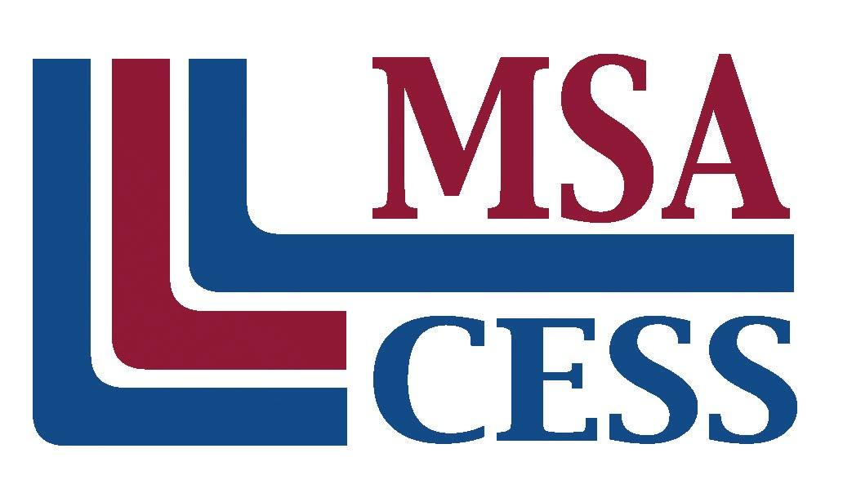
Middle States Association of Colleges and Schools
Commissions on Elementary and Secondary Schools
Phone: 267-284-5000 | www.msa-cess.org

VISITING TEAM MEMBER QUESTIONNAIRE

Full Name with Title (Mr. Ms. Mrs. Dr. Br. Sr. Rabbi Msgr., etc):

Position/Job Title:

School or Organization:

School Address:

School Phone Number: |  | School FAX Number: |  |  |  | School Email
Home Address:

Home Phone Number: | Cell Phone Number: |  |  |  |  |  | Personal Email
Accreditation Experience (Please check all that apply):
Agency:  ◻ MSA  ◻ Other agency:___________________ |  |  | Position:  ◻ Visiting Team Chair ◻ Visiting Team Member ◻ Other experience:  ◻ Assistant Team Chair ◻ Internal Coordinator ________________
Assignment Preferences:
Please prioritize your preference in the following areas on which the team will focus. The number 1 would indicate your highest level of interest; the number 12 would indicate your lowest level of interest.
____ Assessment & Evidence of Student Learning  ____ Information Resources  ____ School Organization and Staff  ____ Student Life & Student Activities |  |  |  | ____ School Improvement Planning  ____ Governance and Leadership  ____ Educational Program  ____ Health and Safety |  |  |  | ____ Student Services  ____ Facilities  ____ Finance  ____ Mission
Skills: How would you describe your writing ability:  ◻ Excellent ◻ Good ◻Fair  How would you describe your computer ability:  ◻ Excellent ◻ Good ◻Fair  Are you able to bring a laptop computer with Microsoft Word to the visit: ◻Yes ◻ No |  |  |  |  | Special Needs: Please note any special needs you may need during the visit.  ◻ Handicapped Accessibility  ◻ Dietary Need (Type)_______________________________________________  ◻ Allergies (Type)_____________________________________  ◻ Other (Passport issues, etc):
IMPORTANT: Please write a short paragraph introducing yourself to the visiting team. Include some personal details, information about your experience and current position, and your interest in accreditation.

